**UNIVERSITY-BANGLADESH**

Choose an item.

**Lab Report**

|  |  |  |  |  |
| --- | --- | --- | --- | --- |
| Assignment Title: | Lab Report | | | |
| Assignment No: | 6 | | Date of Submission: | 30 March 2021 |
| Course Title: | Data Communication | | | |
| Course Code: | 00068 | | Section: | J |
| Semester: | Spring | 2020-21 | Course Teacher: | Md Mehedi Hasan |

**Declaration and Statement of Authorship:**

1. I/we hold a copy of this Assignment/Case-Study, which can be produced if the original is lost/damaged.
2. This Assignment/Case-Study is my/our original work and no part of it has been copied from any other student’s work or from any other source except where due acknowledgement is made.
3. No part of this Assignment/Case-Study has been written for me/us by any other person except where such collaborationhas been authorized by the concerned teacher and is clearly acknowledged in the assignment.
4. I/we have not previously submitted or currently submitting this work for any other course/unit.
5. This work may be reproduced, communicated, compared and archived for the purpose of detecting plagiarism.
6. I/we give permission for a copy of my/our marked work to be retained by the Faculty for review and comparison, including review by external examiners.
7. I/we understand thatPlagiarism is the presentation of the work, idea or creation of another person as though it is your own. It is a formofcheatingandisaveryseriousacademicoffencethatmayleadtoexpulsionfromtheUniversity. Plagiarized material can be drawn from, and presented in, written, graphic and visual form, including electronic data, and oral presentations. Plagiarism occurs when the origin of them arterial used is not appropriately cited.
8. I/we also understand that enabling plagiarism is the act of assisting or allowing another person to plagiarize or to copy my/our work.

*\* Student(s) must complete all details except the faculty use part.*

** Please submit all assignments to your course teacher or the office of the concerned teacher.

|  |  |  |  |  |  |  |  |
| --- | --- | --- | --- | --- | --- | --- | --- |
| **No** | **Name** | **ID** | | **Program** | | **Signature** | |
| 1 | Md.Yousuf Afendi | 19-39887-1 | | BSc [CSE] | |  | |
| ***Faculty use only*** | | | | | | |
| FACULTYCOMMENTS | | | **Marks Obtained** | |  | |
|  | | |  | |  | |
|  | | |  | |  | |
|  | | | **Total Marks** | |  | |
|  | | |  | |  | |
|  | | |  | |  | |

Id:19-39887-1

a)

function dn =asc2bn(txt)

dec=double(txt)

p2=2.^(0:-1:-7)

B=mod(floor(p2'*dec),2)

dn=reshape(B,1,numel(B));

end

b)

clear all;

close all;

Transmitted_Message= '18-39887-1'

%Converting Information Message to bit%

x=asc2bn(Transmitted_Message);

bp=1; %bit duration = 1 sec

disp(' Binary information at Trans mitter :');

disp(x);

%XX representation of transmitting binary information as

bit=[];

for n=1:1:length(x)

if x(n)==1;

se=5*ones(1,100);

else x(n)==0;

se=zeros(1,100);

end

bit=[bit se];

end

t1=bp/100:bp/100:100*length(x)*(bp/100);

subplot(4,1,1);

plot(t1,bit,'lineWidth',2.5);

grid on;

axis([ 0 bp*length(x) -.5 6]);

ylabel('amplitude(volt)');

xlabel(' time(sec)');

title('Transmitting information as digital signal');

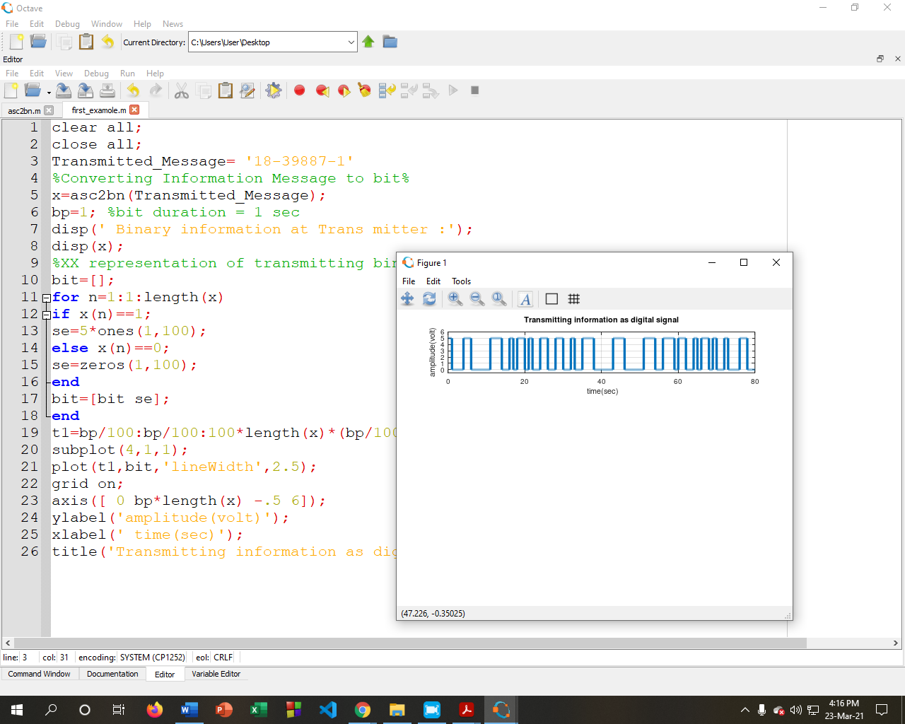

c)

clear all;

close all;

Transmitted_Message= '18-36502-1'

%Converting Information Message to bit%

x= asc2bn(Transmitted_Message);

bp=1; %bit duration = 1 sec

disp(' Binary information at Transmitter :');

disp(x);

%XX representation of transmitting binary information as

bit=[];

for n=1:1:length(x)

if x(n)==1;

se=5*ones(1,100);

else x(n)==0;

se=zeros(1,100);

end

bit=[bit se];

end

t1=bp/100:bp/100:100*length(x)*(bp/100);

subplot(4,1,1);

plot(t1,bit,'lineWidth',2.5);

grid on;

axis([ 0 bp*length(x) -.5 6]);

ylabel('amplitude(volt)');

xlabel(' time(sec)');

title('Transmitting information as Asynchronous digital signal');

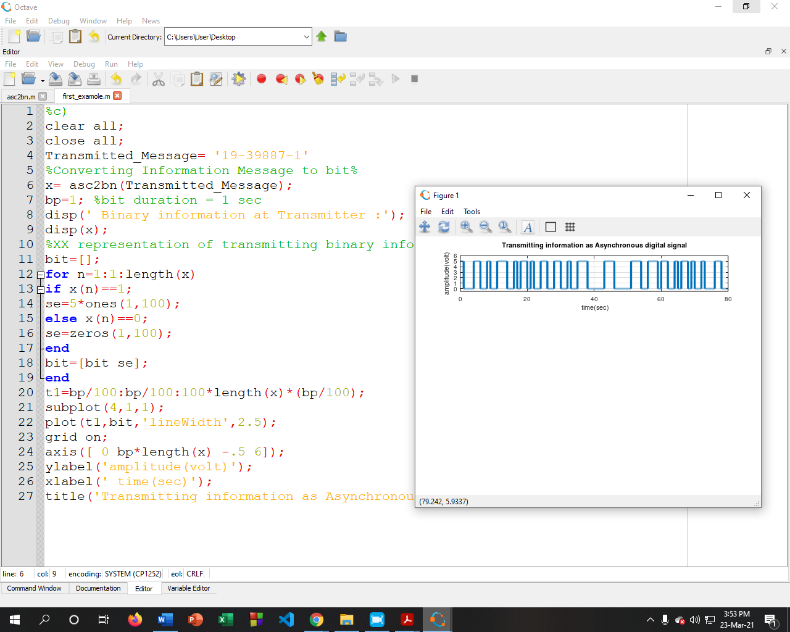

d)

function dn = asc2bn(txt)

dec=double(txt) %Text to ASCII (decimal)

X=size(dec,2);

Y=zeros(1,X)

Z=ones(1,X)

p2=2.^(0:-1:-7) % 2^0,2^-1,.......,2^-7

B=mod(floor(p2'*dec),2) %Decimal to binary conversion

%Columns of B are bits of chars

B=[Y:B:Z]

dn=reshape(B,1,numel(B));%Bytes to serial conbversion

end

Transmitted_Message= '19-398871';

prompt = 'Asynchronus or Synchronus Signal? Please enter "A" for Asynchronus and "S" for Synchronus=';

x = input(prompt,'s')

if x=='S'

x=asc2bn(Transmitted_Message);

bp=1; %bit duration = 1 sec

disp(' Binary information at Trans mitter :');

disp(x);

bit=[];

for n=1:1:length(x);

if x(n)==1;

se=5*ones(1,100);

else x(n)==0;

se=zeros(1,100);

end

bit=[bit se];

end

t1=bp/100:bp/100:100*length(x)*(bp/100);

plot(t1,bit,'lineWidth',2.5);grid on;

axis([ 0 bp*length(x) -.5 6]);

ylabel('amplitude(volt)');

xlabel(' time(sec)');

title('Transmitting information as Synchronus digital signal');

elseif x=='A'

x=asc2bn(Transmitted_Message);

bp=1; %bit duration = 1 sec

disp(' Binary information at Trans mitter :');

disp(x);

bit=[];

for n=1:1:length(x)

if x(n)==1;

se=5*ones(1,100);

else x(n)==0;

se=zeros(1,100);

end

bit=[bit se];

end

t1=bp/100:bp/100:100*length(x)*(bp/100);

plot(t1,bit,'lineWidth',2.5);

grid on;

axis([ 0 bp*length(x) -.5 6]);

ylabel('amplitude(volt)');

xlabel(' time(sec)');

title('Transmitting information as Asynchronus digital signal');

else

disp('Warning: Invalid Input! Please type "A" or "S"!!');

end

**Synchronous Transmission:**

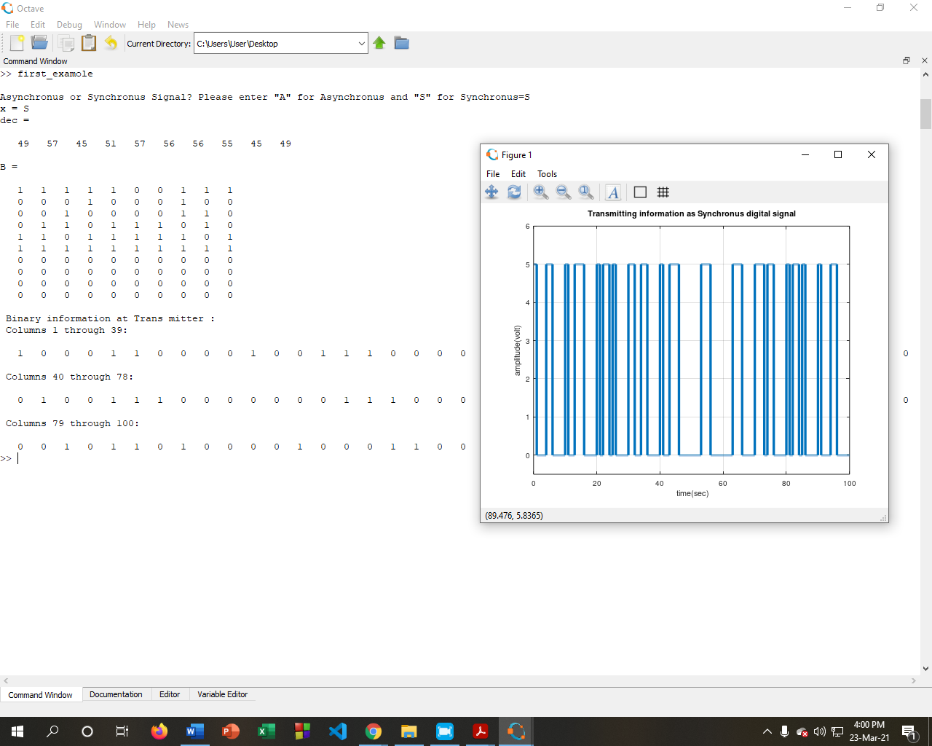

**Asynchronous Transmission:**

